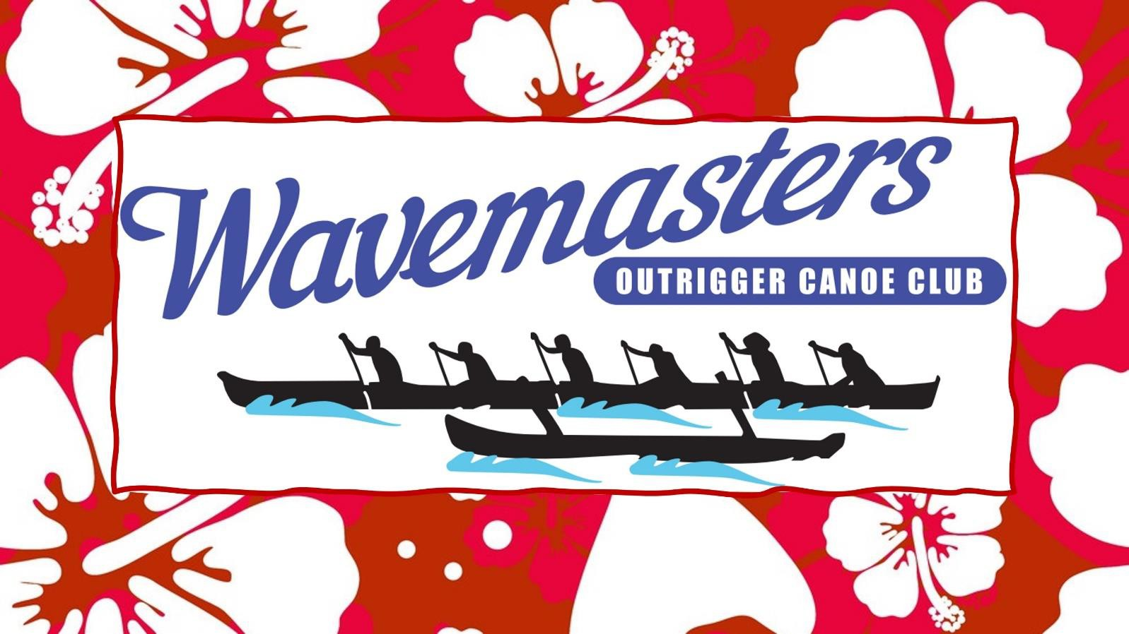

***Presents....***

# The JUNIOR

MIGHTY MONKEY’S

relay

# Koombana Beach

## Saturday 1st Feb 25 Home of the monkeys

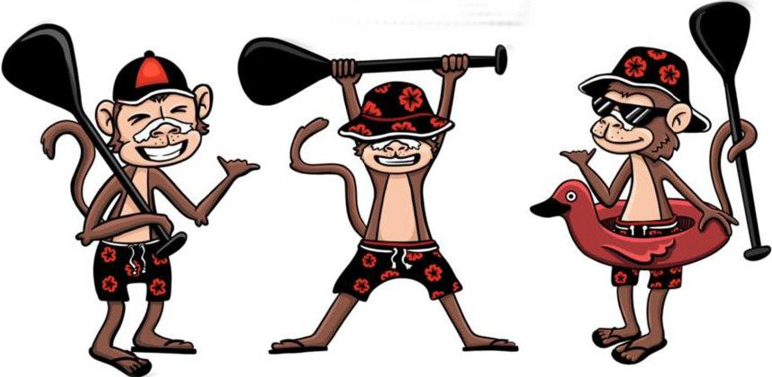



***WESTERN AUSTRALIA***

OUTRIGGERS

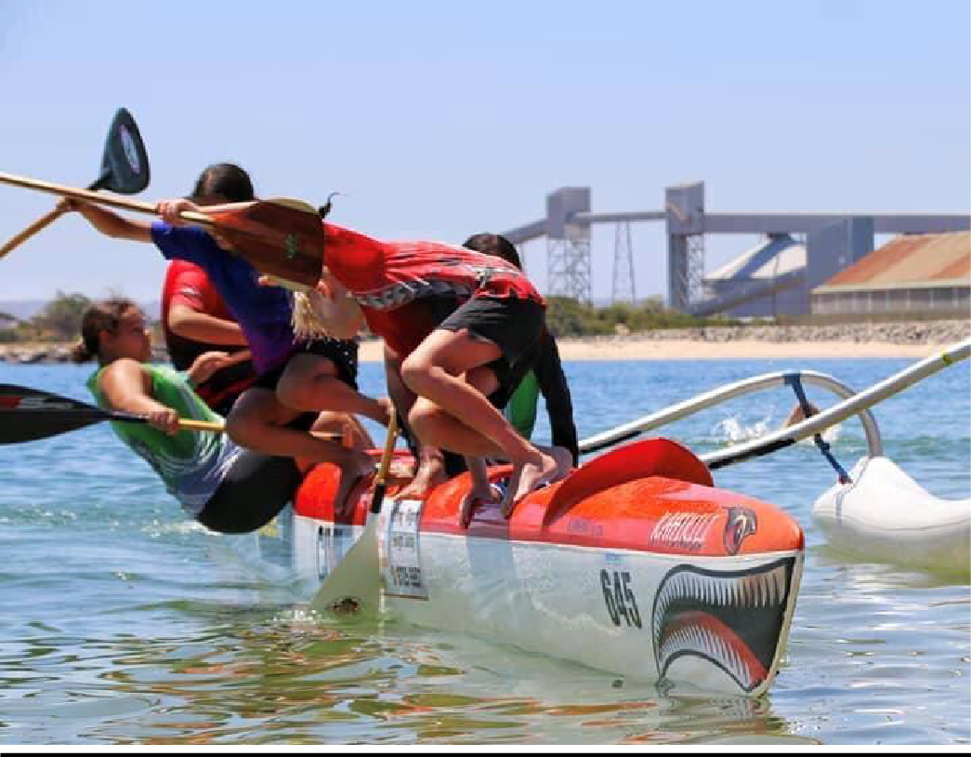

**Race Program**

**8.00AM Sign in and Scrutineering**.

**9.00AM Race Brief.**

**9.30AM Races Start.**

**AGE GROUP V1 2km. 12u.**

**14u.**

**16u.**

**19u.**

**Mighty Monkeys relay.**

**LAP 1. Minnows 1km triangle, ADULT STEERER LAP 2. 12u 2km triangle.**

**LAP 3. 14u 2 X 2km triangle. LAP 4. 16u/19u 2 x 2km triangle**

**LAP 5. Minnows 1km triangle, ADULT STEERER LAP 6. 12u 2km triangle.**

**LAP 7. 14u 2 X 2km triangle.**

**LAP 8. 16u/19u 2 x 2km triangle.**

**Changes will be shallow water, as per senior monkeys.**

**3.00PM Presentations at Koombana beach.**

**Course map. Green 2km course. Red 500m ish course**

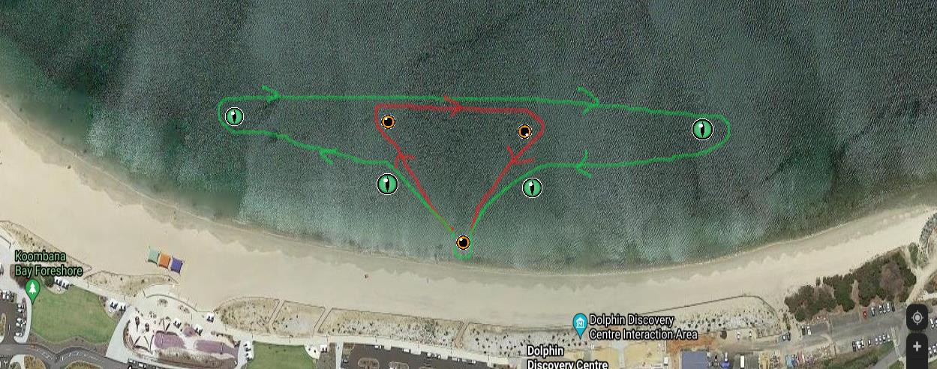

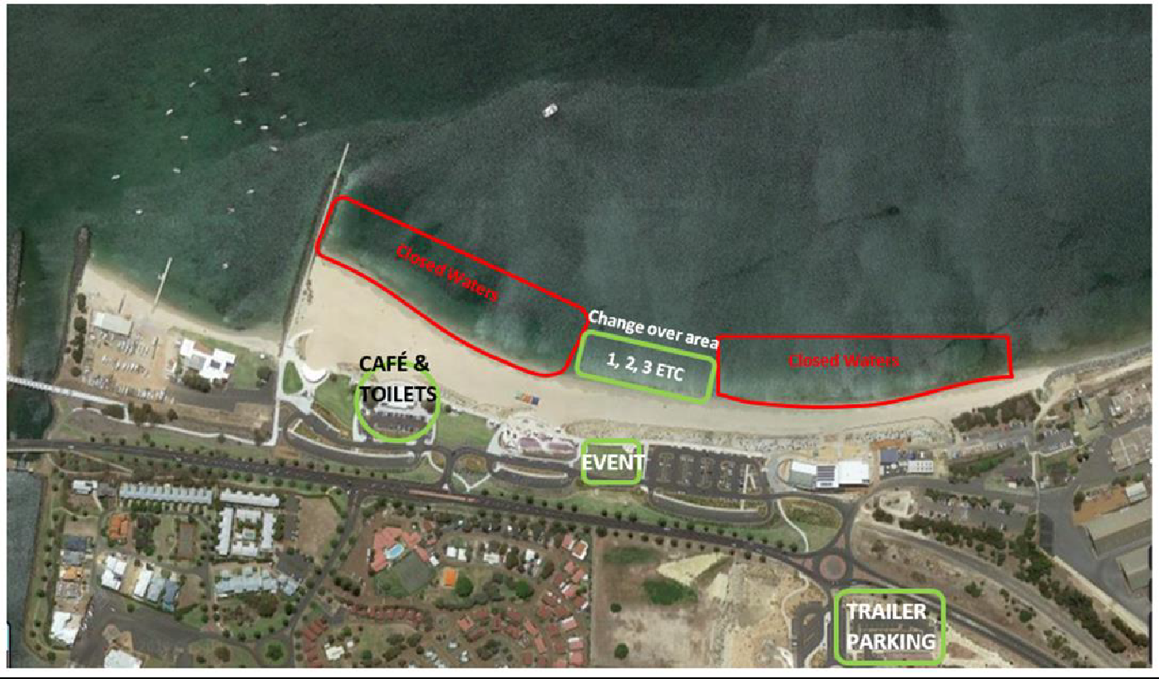

***Entry***

$15pp via the AO website.

REGOS

|  |  |
| --- | --- |
| Mighty Monkeys Junior Relay |  |
|  |  |
| CLUB REGOS IN | 24th Jan |
| TEAM REGOS IN | 25th Jan |

***How to register on the AO site.***

***Club nominations as per usual, age group genders and numbers of.***

***Please Send us your paddlers team registrations with all your age groups in one Rego. Steerers in notes.***

***e.g., one for all the 12u participating, one for the 14u participating etc. because this format is new for juniors, we will be placing paddlers in teams, where we can, we will keep clubs together as much as possible.***

***Please send separate team registrations for the V1 paddlers. Put V1 in notes. Please note we will need to pool our V1s, and we will need OC6s.***

***Contact Connie with your craft availability.***

***Safety Equipment***

* All canoes must carry 6 x PFD’S type 50 S or better. They must be secure and easily accessible.
* A minimum of 2 buckets or similar pieces of equipment to be used to bail out a canoe. They must be secure and easily accessible.
* A minimum of 1 spare paddle
* A towrope (of 25 metres minimum length by 12 mm diameter, tied to the forward spreader, secured outside the covers and available for immediate use)
* Storm covers are permitted at any time and are compulsory at the discretion of the Race Director.
* An Inshore Distress Flare Kit (in Date.)
* V1s life jackets. Bailer, Lanyard.
* Minnows must wear a pfd.



This Race will be run in accordance with the new AO rules. https://aocra.com.au/uploads/file/AOCRA%20Admin%20/2023%20March%20Aocra%20Rules.pdf

***Locations***

Race Event = Koombana Beach, Anchorage Cove, Bunbury.

Presentation’s Koombana

***Rigging***

Lawn areas Koombana Beach, Anchorage Cove. Lawn area Cobblestone Drive Car Park.

Ensure you listen carefully at the briefing and to the Beach Marshalls. Event Location is for First Aid, Rego, Briefing, Team tents and spectators.

## BRING LUNCH ECT……….

This course is subject to change, depending on conditions.

**ALL PADDLERS ARE ENCOURAGED TO FOLLOW THE SUNSMART MESSAGE OF SLIP, SLOP & SLAP THROUGHOUT THE DAY.**

**ALL PADDLERS ARE TO ENSURE THEY ARE ADEQUATELY HYDRATED DURING THE RACE.**

